**PHONE BOXES IN ITALY:** *FROM THE FLOURISHING ERA TO THE SAD ABANDONMENT OF THE NEW MILLENIUM*

For our society, communicating has always been something very important. However, just a few decades ago, the distance between individuals was seen as a problem.

At the end of the 19th century, Meucci invented the telephone: a new instrument that gave the possibility to two (or more) far-located people to communicate with each other directly

However, the well known desk phones couldn’t allow anyone to have a call outside their home. The only solution was to find a place that had a telephone and ask for permission, or to spot one of the rare PTP (*Posti Telefonici Pubblici*) located in bigger urban areas.

Taking a cue from this issue, a company in Italy thought to transform it as an occasion to make business, and invented something totally new for our country: **the phone box.**

In 1952, on the 10th of February the Stipel installed in Piazza San Babila of Milan the first italian phone box. It was very simple: a small soundproof cabin containing a phone with a slot for coins. Italians already knew how and why a phone box was made, thanks to the foreign influence, especially by UK.

Strangely, the success of phone boxes in other countries didn’t encourage our government to sustain this sector. As a matter of fact, this first cabin in Piazza San Babila was just an idea of the company, without any demand coming neither from the country, nor from the town hall.

Luckily, after a period of analysis and considerations, the whole system began to be understood and supported by the country and by national businesses. The phone boxes received much attention: the general aim was to expand their functions, discover new particularities and techniques, spreading them in the fastest possible way along the peninsula. Even remote places, that had been living isolated from the developing society for years, were given the possibility of a phone connection thanks to the installation of a modest cabin in the village.

The 70’s of the last century were the years in which the phone box in Italy finally flourished. The new company “SIP” undertook an exciting campaign: in just 10 years the phone box in our peninsula grew from 2.000 to 33.500. The classical phone box in Italy distinguished from the foreigners for their shape and colour. In Italy, most of them were yellow, and inside them there were two main objects: the phone and a special box that changed coins into specific tokens that could be inserted.

In those times, some technical aspects radically changed: in 1976 was for the first time experimented with the usage of a magnetic prepaid card. Having a card to use was largely easier than putting coins or tokens every minute during a call. The function of the prepaid card was smarter, as everything was done automatically by an internal calculator that scaled down credit until the end of the call or the end of the cash charge. At the same time, also the phones inside cabins were developed, the first U+I was replaced by the new orange Rotor or by the G+M , two more modern prototypes that worked better.

After the end of the 90s, simultaneously with the introduction of the euro and the great distribution of mobile phones, the history of phone boxes changed. They began to be year by year less used, reaching a definitive drastic low peak in 2007. In 2010, the Agcom allowed Telecom to begin the process of removal. In the first years of the last decade, many of them, but not every cabin was dismissed.

Still now, it is possible to find working phone cabins in urban areas, however it is impossible to find a persona using them. New technologies easily overtook phone boxes, making them just sadly abandoned corners of our cities.

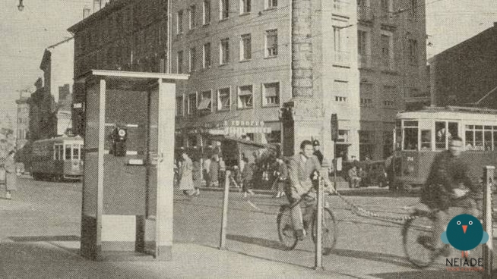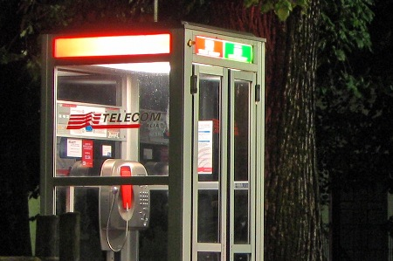

*First Phone Box, Milan Modern Phone Box*

*SOURCES:*

Andrea Cardillo, *La Scomparsa delle Cabine telefoniche*, 2021, Calibano Editore

Marco Saporiti, *Storia della telefonia in Italia*, 2013, Cerbero Editore

<https://www.upgo.news/cabina-telefonica/> (Consulted on 7/05/2022)

<https://www.treccani.it/90anni/parole/1952-cabina-telefonica.html> (Consulted onl 7/05/2022)

<https://www.ideeideas.it/press/La_storia%20_della_cabina_telefonica.pdf> (Consulted on 7/05/2022)

<https://www.redhotcyber.com/post/cabine-telefoniche-che-passione/> (Consulted on 7/05/2022)

<https://m11.altervista.org/blog/la-storia-delle-cabine/> (Consulted on 15/05/2022)

<https://curiosando708090.altervista.org/cabina-telefonica-passato/> (Consulted on 15/05/2022)